https://en.wikipedia.org/wiki/Skull_and_Bones

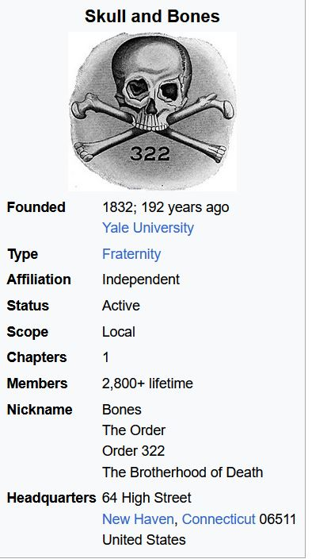

Skull and bones, 322 . . .
A document in Yale's archives suggests that 322 is a reference to the year 322 B.C. and that members measure dates from this year instead of from the common era. In 322 B.C., the Lamian War ended with the death of Demosthenes and Athenians were made to dissolve their government and establish a plutocratic system in its stead, whereby only those possessing 2,000 drachmas or more could remain citizens. Documents in the Tomb have purportedly been found dated to "Anno-Demostheni". Members measure time of day according to a clock 5 minutes out of sync with normal time, the latter is called "barbarian time".
One legend is that the numbers in the society's emblem ("322") represent "founded in '32, 2nd corps", referring to a first Corps in an unknown German university.
Members are assigned nicknames (e.g., "Long Devil", the tallest member, and "Boaz", a varsity football captain, or "Sherrife" prince of future). Many of the chosen names are drawn from literature (e.g., "Hamlet", "Uncle Remus"), religion, and myth. The banker Lewis Lapham passed on his nickname, "Sancho Panza", to the political adviser Tex McCrary. Averell Harriman was "Thor", Henry Luce was "Baal", McGeorge Bundy was "Odin", and George H. W. Bush was "Magog".

Skull and bones, 322 . . . Genesis 3:22 . . .

Genesis 3:22
22 And the Lord God said, Behold, the man is become as one of us, to know good and evil: and now, lest he put forth his hand, and take also of the tree of life, and eat, and live for ever:
322 & the Illuminati Chapter of the Order of Skull & Bones
http://pentracks.com/2015/12/322-the-illuminati-chapter-of-the-order-of-skull-bones/
Posted on December 13, 2015
322 and THE ILLUMINATI CHAPTER OF THE ORDER OF SKULL and BONES. This post is in answer to the question, “do you have any idea what the 322 means in skull and bones”? The short answer is “yes”, the longer answer forms this article. 322 is a sacred number for the members of the Order of Skull and Bones, and they refuse to talk about its meaning. The number is placed under their skull and bones “logo” and on their Tomb door (their frat building at Yale is called “the Tomb” which contains their temple). The floor of the Temple within the Tomb also has 322 inlaid on its floor.
The Illuminati bloodlines, which hid themselves within the Rosicrucians and Freemasons during the 1700’s, sponsored the German Philosopher Adam Weishaupt to form a branch of the Illuminati which would promote their agenda. He began this in 1776 in Bavaria. Soon afterwards, an affiliate began in the U.S. in Virginia called Phi Beta Kappa. (See Phi Sigma Omega and Fraternal Societies, http://www.ipsonet.org/other-projects/phi-sigma-omega-and-fraternal-societies for further reference, https://en.wikipedia.org/wiki/Phi_Beta_Kappa). Phi Beta Kappa transferred its base to Yale, and set up a chapter also in Harvard. It’s rituals were based on Egyptian magic, Masonic in nature, and they “Illuminated” their candidates. Another early secret society of Yale, Society of Brothers in Unity, https://en.wikipedia.org/wiki/Brothers_in_Unity, had Joseph Dulles in it…his progeny John Foster Dulles and Allen Dulles (assoc. with Rockefellers) show up in the public eye a century later. In 1825, there was a public outcry against secret societies after the murder of the former Freemason Captain William Morgan, https://en.wikipedia.org/wiki/William_Morgan_(anti-Mason), who turned against the organization, https://en.wikipedia.org/wiki/Anti-Masonic_Party#Background. The first third-party political party in the United States of America was the Anti-Masonic party, which attacked secret societies and the power they had in America, https://en.wikipedia.org/wiki/Anti-Masonic_Party. In 1832, the Harvard Phi Beta Kappa chapter decided to quit being secret, and sent a rep to the Yale chapter telling them so. Seeing the “handwriting on the wall” so to speak, the Yale Phi Beta Kappa decided to become an open society, which before the century was out, faded into non-existence. In its place, the smaller, more obscure Order of the Skull and Bones was created by several Phi Beta Kappa members.
The main Phi Beta Kappa founder of the Order of the Skull and Bones was William Huntington Russell, a member of the Russell Illuminati bloodline, as well as an initiate of a German chapter of the Bavarian Illuminati, which he had participated in the during 1831-32 time period when he was student there. He also founded a prep school for elite boys, and this led to the Phillips Academy (prep school) for the elite. The Bavarian Illuminati continues in Bavaria even today. They are a branch of the Illuminati, and Skull and Bones are a branch of the Bavarian Illuminati; they practice the same rituals that were exposed by the respected Freemason John Robinson in his Proofs of a Conspiracy book exposing the Bavarian Illuminati, and its takeover of Freemasonry, https://en.wikipedia.org/wiki/John_Robison_(physicist).
In the occult world, things have an exoteric (Exoteric: Not belonging, limited, or pertaining to the inner or select circle, as of disciples or intimates.) name and meaning along with the hidden occult name and meaning (called the esoteric or arcane). Skull and Bones has an esoteric (Esoteric: Understood by or meant for only the select few who have special knowledge or interest; belonging to the select few; private; secret; confidential.) name which is “The Order 322”. The obvious meaning of 322 is that it was the second chapter of this Bavarian Illuminati chapter which began in 1832. However, obvious things sometimes are not so obvious . . . that begs the question why people like President Bush and Senator John Kerry would refuse to say anything about 322. The Kabala, gematria, and sacred numbers are the foundation of the occult. Satanist Aleister Crowley wrote “777”. William Wynn Wescott, https://en.wikipedia.org/wiki/William_Wynn_Westcott, said in this book “The Occult Power of Numbers” (p. 15): “. . . Numbers are a key to the ancient views of cosmogony . . . spiritually as well as physically . . . to the evolution of the present human race; all systems of religious mysticism are based upon numerals. The sacredness of numbers . . .” William Wynn Wescott co-founded the Hermetic Order of the Golden Dawn with Samuel Liddell MacGregor Mathers and William Robert Woodman in 1887, using the motto V.H. Frater Sapere Aude.
The Hermetic Order of the Golden Dawn (Latin: Ordo Hermeticus Aurorae Aureae; or, more commonly, the Golden Dawn (Aurora Aurea)) was an organization devoted to the study and practice of the occult, metaphysics, and paranormal activities during the late 19th and early 20th centuries. The Hermetic Order of the Golden Dawn was known as a magical order.
Around this time, he was also active in the Theosophical Society, where he founded in 1891 The Adelphi Lodge in London WC.
The number 322 is used by Skull and Bones members in many ways, showing that it is considered a sacred number.
Where and how the Illuminati operate must be understood in order to realize the bigger context of what Skull and Bones operates within. Skull and Bones business name is the Russell Trust Association.
Skull and Bones are but a chapter of something much more powerful and global. This is how a 1943 special Connecticut legislative act, https://en.wikipedia.org/wiki/Russell_Trust_Association, gave their Skull and Bones legal corporation special exemption from having to file corporation reports. It is why Prescott Bush could be publicly proven to be an agent working with the Hitler regime after the U.S. went to war, and yet he was able to keep and use his profits to finance his family going into politics after the war. As the members of Skull and Bones are members of a much larger secret society, you can see the Skull and Bones members throughout history move around with incredible power. You would expect the occult meaning of 322 to be much bigger than the Skull and Bones.
NEW BEGINNINGS. The Vernal (Spring) Equinox falls on March 21. The first day of Aries (the first astrological sign) is March, 22nd. The Illuminati do celebrate the Spring equinox with rituals. In essence, 3/22, or 322 is the beginning of the new year. 1832, was the beginning of Skull and Bones, but more important 3-22, or 322 is the beginning of the new year. The Skull and Bones, along with the rest of the Illuminati, look forward to the beginning of a new age – a new world order, the return to the Golden Age. The word “Revolution” was coined because (according to Illuminati occult beliefs) violent revolutions would revolve us back to the Golden Age. So 322 is a symbol of the New Order, the new beginnings, "the new spring," that the Illuminati strive to bring in. Two Skull and Bones brothers, Captain Prescott Bush and Captain Henry Mallon were assigned to the 322nd Regiment of Field Artillery. The President George W. Bush was fined $3.22 for missing a Skull and Bones meeting. The Skull and Bones Class of 1858 gave a note: “322 from the S.E.C. of 1858”. The overall Headquarters capital for the Illuminati is Brussels, Belgium, whose city code is 322. The Skull and Bones members add 322 to our calendar year to derive their cult date, in other words this year is 2018 + 322=2340. The number 322 is not assigned as an area code in the United States. Area Cod 321 is East Central Florida’s Brevard County, Florida where Cape Canaveral, JFK Space Center, Patrick AFB, and a U.S. Navy test unit are located. This is just north of Jupiter Island, part of Treasure Coast and an important Illuminati private island. Area Cod 323 is the Hollywood-central LA area. (Note: Scams have frequently used Area Code 322 for their scam phone numbers).
THE ELITE LIKE PRIVACY . . . Jupiter Island, Florida is tied to Skull and Bones. Bonesmen Prescott Bush and Averell Harriman were part of Jupiter Island. Jupiter Island was bought in 1931 to use as a secret elite community. (Deer Island is another private Skull and Bones island used as the site of a club house.) When a judge dismissed a case against Jupiter Island, he said, “The community is unique – it is the one and only, different from all others, having no like or equal. It is unusual, extraordinary and rare. It was cut from one mold and its counterpart cannot be found elsewhere. Many people would consider it dead – but it is very much alive with genteel living, friendship and compatibility. The Town doesn’t want what many others have, but many others would be better off if they had more of what this Town has and wants to keep- seclusion, solitude and tranquility.” Richard M. Bissell, Jr. of the Bissell Illuminati family was associated with the Island. His father, Richard M. Bissell, Sr. ran a mind-control project called Neuro Psychiatric Institute, which used one of its victims to create the Mental Hygiene Society, which was a Skull and Bones mind control project years before Project MKUltra, https://en.wikipedia.org/wiki/Project_MKUltra. Bissell, Jr. joined the CIA as one of Allen Dulles’ close aides. He and other Bonesmen worked with creating Cuban assassination squads. (By the way, Antony C. Sutton, https://en.wikipedia.org/wiki/Antony_C._Sutton, who exposed the Skull and Bones, America's Secret Establishment: An Introduction to the Order of Skull & Bones, https://www.amazon.com/Americas-Secret-Establishment-Introduction-Order/dp/0972020748 -- speculated that Skull & Bones had played an important role in coordinating the political and economic relationships underlying the historical events -- happened to die on June 17th, the date Skull and Bones was founded and the ritual feast day of Corpus Christi mocking Christ.) The Dulleses were in Princeton secret societies. It was said that the occult families of the secret Eastern establishment that fed into groups like Skull and Bones, Wolf’s Head, Porc Club, Scroll and Key which also use secret cult names for its members numbered 32 bloodlines.

Saudi Arabia, because of its Council on Foreign Relations, CFR, (Roman Catholic "church,) created cartel-capitalist oil monopoly, finances the Black "pope's" (the Jesuit General's) International Terrorist Network, www.alemattec.com/Pope gives MARCHING ORDERS to Jesuits and their new Superior General . . .htm, www.alemattec.com/Pope gives MARCHING ORDERS to Jesuits and their new Superior General . . . .doc. This Network is overseen by the "Father Jesuit General's" Central Intelligence Agency, CIA, which in turn has been consistently directed by the Council on Foreign Relations, CFR, affiliates since its inception. CFR members being either oath bound Knights of Malta, 33rd Degree Freemasons or members of Yale's Satanic Brotherhood known as "Skull and Bones."

This is what it's like to eat at the secret Disneyland club that has a 14-year waiting list
http://www.businessinsider.com/club-33-in-disneyland-review-2017-8
At the top of the windows there are designs that are almost “shaped like an eye." Spooky stuff! Membership in Club 33 (in 2003) is $7,500, with yearly dues of $2,500. A buffet-style meal is $47.

The Walt Disney Agenda
- by Wes Penre for Illuminati News, July 4, 2004
http://www.illuminati-news.com/walt-disney-agenda.htm

Walt Disney: The Gnostic Masonic Rosicrucian
http://gnosticwarrior.com/walt-disney.html

The Burning Taper
http://burningtaper.blogspot.com/2007/06/disney-masonic-connection.html

Souvenir Friday- Disneyland Masonic Club Badge
http://matterhorn1959.blogspot.com/2007/06/souvenir-friday-disneyland-masonic-club.html

Ronald Reagan was made both and honored Mason and an honorary Shriner.
http://www.bessel.org/reagan.htm
also, go here: Upper left of page goto page #50.
https://www.dcgrandlodge.org/uploads/6/9/5/4/6954862/history_1962-1991#page=50.pdf
Note: In the upper left-hand corner where it displays 1 of 93, change the one to a 50.
https://www.alemattec.com/History--1962-1991.pdf
On February 11, 1988, several Masonic officials visited President Ronald W. Reagan in the Oval Office of the White House. Among the Masons present were:
Most Wor. Raymond F. McMullen
Grand Master of Masons of the District of Columbia
Most Wor. Stewart W. Miner, PGM
Grand Secretary of the Grand Lodge of the District of Columbia
Wor. William E. Chaney, Jr.
Grand Marshal of the Grand Lodge of the District of Columbia
Ill. Francis S. Paul
Sovereign Grand Commander of the Scottish Rite, Northern Masonic Jurisdiction
Sidney R. Baxter
Assistant to the Sovereign Grand Commander, Northern Masonic Jurisdiction, A.A.S.R.
Ill. C. Fred Kleinknecht
Sovereign Grand Commander of the Scottish Rite, Southern Jurisdiction
Carroll M. Bowman
Assistant Grand Secretary General, Southern Jurisdiction, A.A.S.R.
Ill. Voris King
Imperial Potentate of the A.A.O.N.M.S. (Shrine) of North America
Jack H. Jones
Imperial Recorder, A.A.O.N.M.S. (Shrine) of North America
The Grand Master of D.C. presented President Reagan with a "Certificate of Honor," which said that President Reagan's life was a testament to his firm belief in brotherly love, relief, and truth, and his service to the public has broadened the applications of temperance, fortitude, prudence, and justice to the benefit of all mankind. This Certificate further said that in recognition of President Reagan's efforts to promote good will and understanding throughout the world, this certificate was issued to him by the Grand Master of D.C. on February 11, 1988. A complete copy of the Certificate is printed at page 67 of the 1988 D.C. Proceedings.
According to a press release issued by the D.C. Grand Lodge, the two Scottish Rite Grand Commanders jointly gave President Reagan a Scottish Rite Certificate, and the Imperial Potentate gave him a Shrine certificate. According to The New Age Magazine and The Northern Light Magazine, the Scottish Rite Grand Commanders jointly presented President Reagan with a certificate (a copy of which is shown in The Northern Light Magazine, April 1988 issue, page 12) that "conferred the title of Honorary Scottish Rite Mason," and the Imperial Potentate presented him with a certificate with the designation "Honorary Member of the Imperial Council" of the Shrine. The Northern Light Magazine pointed out that the certificate of honor presented by the Grand Lodge of D.C. "should not be confused with the 'Mason-at-sight' ceremony performed by a number of other Grand Lodges."
President Reagan gave Grand Master McMullen, Sovereign Grand Commanders Paul and Kleinknecht, and Imperial Potentate King, "Private Section Initiative Commendations" for the charitable and philanthropic programs of the Masonic organizations.
In a February 22, 1988, letter from President Reagan to Grand Commander Kleinknecht (a copy of which was printed in The New Age Magazine, April 1988, inside front cover), the President said he commended "the outstanding charitable work of the Masons as one of our nation's oldest fraternal organizations." He also thanked the Scottish Rite, Southern Jurisdiction, Grand Commander, for "the framed certificate of membership," and said he was "honored to join the ranks of sixteen former Presidents in their association with Freemasonry."
Later, it is noted in the 1988 D.C. Grand Lodge Proceedings that the Grand Master issued a Decision in which he said that a non-resident Mason, regularly employed in full time Masonic work within Washington, D.C., challenged the authority of the Grand Master and the Grand Lodge. In response, the Grand Master ruled that the authority of the Grand Master and the Grand Lodge extended to the exercise of sovereignty within the confines of that Grand Lodge (Washington, D.C.) over all Masons, resident or transient, so long as they are physically within the confines of that Grand Jurisdiction.
Then, on September 23, 1988, the Grand Master issued an Edict, which said that Brother C. Fred Kleinknecht, Sovereign Grand Commander of the A.A.S.R., Southern Jurisdiction is a sojourning Mason employed within the confines of the Grand Jurisdiction of D.C. and therefore subject to the laws, rules, and regulations of the Grand Lodge of D.C., and he has "persistently and willfully disregarded the authority" of the Grand Lodge of D.C. and the courtesies due all Grand Lodges and Grand Masters, and he had "scornfully rejected lawful requests" to him by the Grand Master of D.C. to appear in response to an official Summons issued by the Grand Master, and has "unilaterally assumed the right to edit, without the concurrence of the Grand Master or the Grand Lodge, a White house produced tape account of a Masonic visit with the President in the Oval Office on February 11, 1988.; Therefore, the Grand Master issued an Edict which said Brother Kleinknecht was suspended from all the rights and benefits accorded Sojourning Masons in that jurisdiction, and all Masons all D.C. Masons that so long as that Edict was in effect all Masonic intercourse with him was illegal.
The Proceedings say that after the issuance of this Edict, the Grand Master of Maryland acted as a mediator in an effort to settle this dispute. On October 6, 1988, in the office of the Grand Master of Maryland, the Grand Master and Grand Secretary of D.C. met with the Sovereign Grand Commander and his Grand Secretary General, who was also a Past Grand Master of D.C. The Grand Secretary of Maryland was also present. An "accommodation" was arrived at, and the Maryland Grand Master issued an announcement, and the D.C. Grand Master rescinded his Edict on October 20, 1988, saying that at the Maryland meeting Kleinknecht had "transferred custodianship of the White House produced tape of a Masonic visit with the President in the Oval Office on February 11, 1988, along with all known complete copies made of that tape, to Grand Master Bryan for safe keeping in the office of the Grand Lodge of Maryland." It also said that during the meeting Kleinknecht had acknowledged the "primacy" of the Grand Master of D.C. within his jurisdiction, and he and the Grand Master has signed a "memorandum of understanding" prepared by the Maryland Grand Master and distributed by him to all Grand Lodges in the U.S. Therefore, the Grand Master's Rescission Edict stated that Brother Kleinknecht was restored to all the rights and benefits due Sojourning Masons in the jurisdiction of the Grand Lodge of D.C.

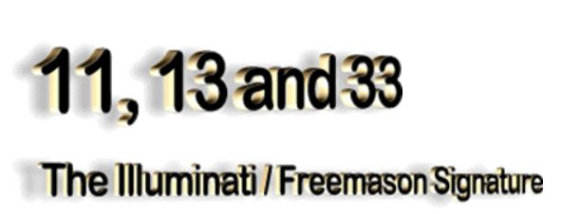
http://www.bibliotecapleyades.net/sociopolitica/esp_sociopol_illuminati_14.htm

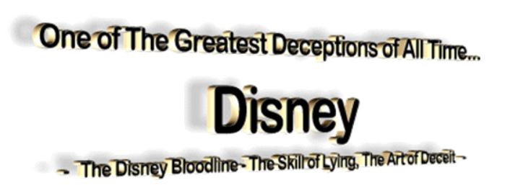
http://www.bibliotecapleyades.net/bloodlines/disney1.htm

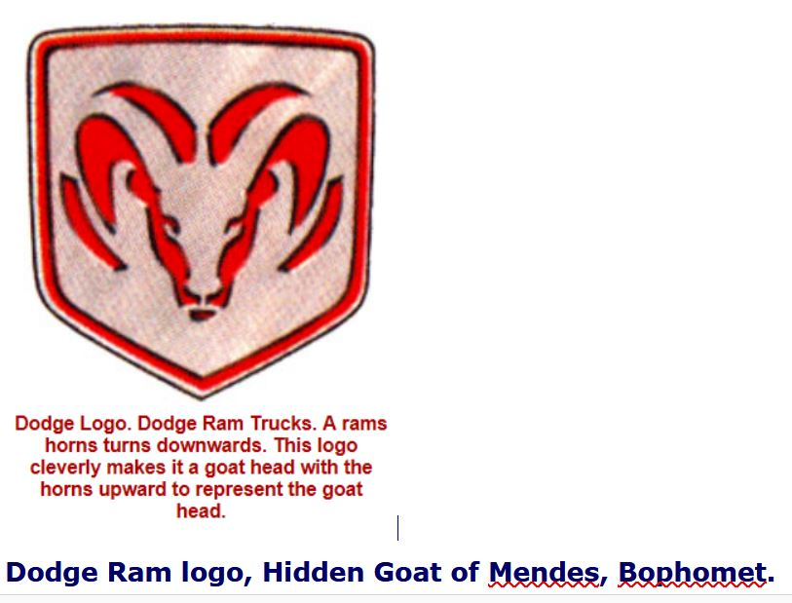
https://en.wikipedia.org/wiki/Baphomet#Goat_of_Mendes

A famous mason Manly P. Hall stated the following,
"When the Mason learns that the key to the warrior on the block is the proper application of the dynamo of living power, he has learned the mystery of his Craft. The seething energies of Lucifer are in his hands and before he may step onward and upward, he must prove his ability to properly handle energy."
(Manly P. Hall, The Lost Keys of Freemasonry, p. 124;)
The 33 degrees was no mistake.
Its like the temperature, 32 and below is frozen (not knowing) at 33 it thaws (knowing). --

Paul (<:) Jesus first!
www.Alemattec.com

