Matthew 6:9-13  King James Version  9 After this manner therefore pray ye: Our Father which art in heaven, Hallowed be thy name.  10 Thy kingdom come, Thy will be done in earth, as it is in heaven.  11 Give us this day our daily bread.  12 And forgive us our debts, as we forgive our debtors.  13 And lead us not into temptation, but deliver us from evil: For thine is the kingdom, and the power, and the glory, for ever. Amen. | Matthew 6:9-13  The Message (Modern Day 'easy to understand') 'bible'. Who Do You Think They 'worship'?  9-13 “The world is full of so-called prayer warriors who are prayer-ignorant. They’re full of formulas and programs and advice, peddling techniques for getting what you want from God. Don’t fall for that nonsense. This is your Father you are dealing with, and he knows better than you what you need. With a God like this loving you, you can pray very simply. Like this:  Our Father in heaven,  Reveal who you are.  Set the world right;  Do what’s best—  as above, so below.  Keep us alive with three square meals.  Keep us forgiven with you and forgiving others.  Keep us safe from ourselves and the Devil.  You’re in charge!  You can do anything you want!  You’re ablaze in beauty!  Yes. Yes. Yes.  Note: ' . . . as above, so below.' is satanic, Masonic. 'As Above So Below' is a famous Masonic maxim.
Baphomet (Goat Of Mendes Of Egypt) aka satan (transgender with woman's breasts).

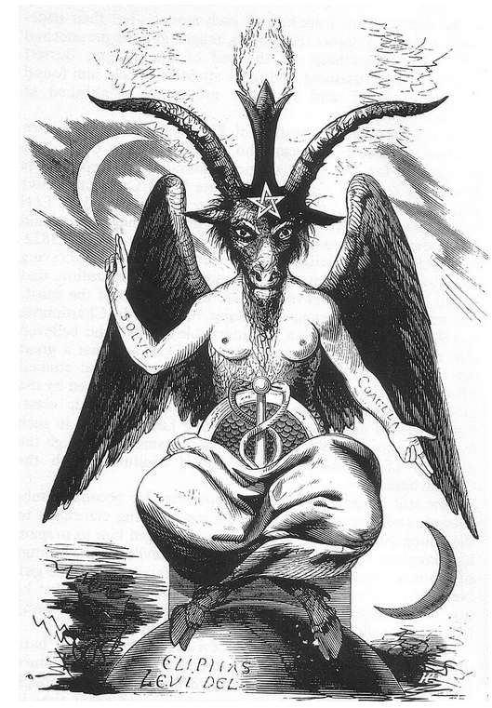
Tom Hanks in the movie Forrest Gump, saying goodbye to Jenny, flashes the Mark Of Baphomet (Goat Of Mendes Of Egypt) aka displaying his worship of satan

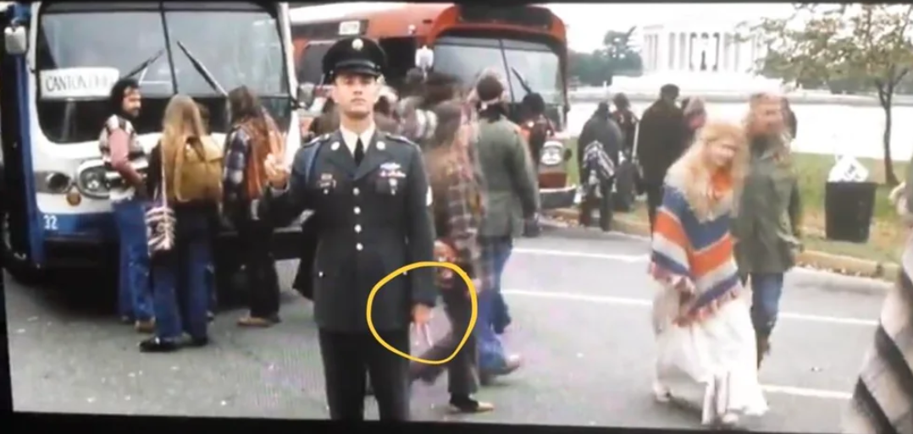
Most people believe the G below in the compass of the Masons stands for God. Masons are controlled by the Illuminati who are controlled by the Jesuits. G stands for the VERY WEALTHY Jesuit (Church of the Gesù -- Latin for Jesus: Chapel of Saint Ignatius -- Jesuits are suppose to take a vow of (one) 'possessed' I mean, of poverty) instead, it is the extremely wealthy “Mother church” . . .

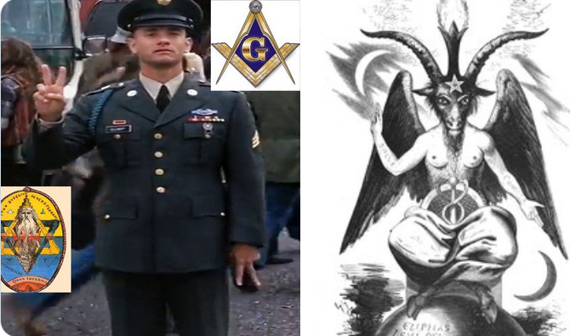
Most people believe the G above in the compass of the Masons stands for God. Masons are controlled by the Illuminati who are controlled by the Jesuits. G stands for the VERY WEALTHY Jesuit (Church of the Gesù -- Latin for Jesus: Chapel of Saint Ignatius -- Jesuits are suppose to take a vow of (one) 'possessed' I mean, of poverty) instead, it is the extremely wealthy “Mother church” . . .

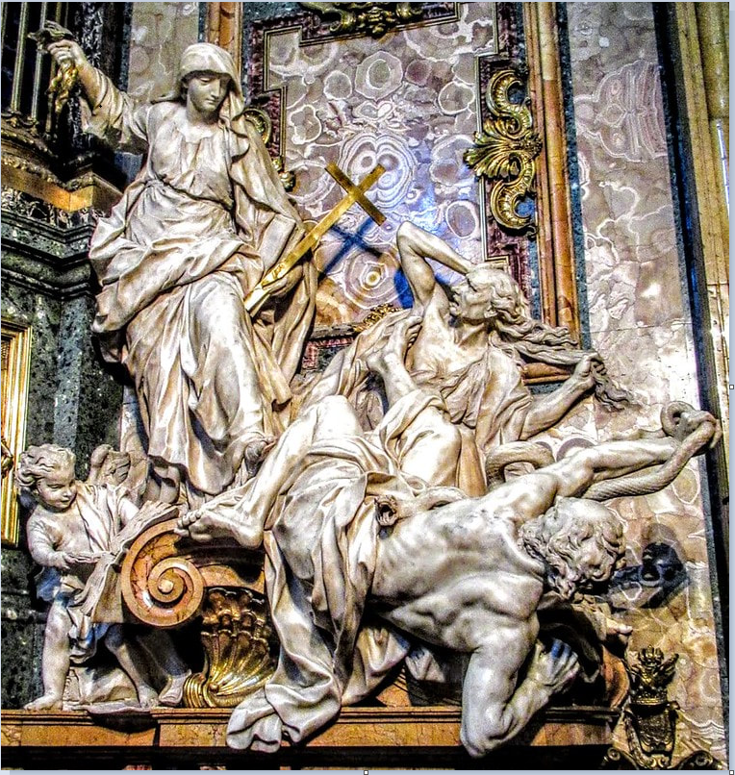

Statue On The Right Of The satanic Jesuit 'church' of Gesu Alter (When Facing The Alter,) The Mother 'church' Represented By The Woman -- Punishes, Tortures, Murders, The So Call Hereticks, i.e.--Protestants. Notice, the description by the satanic Jesuits – Masterpiece Of Pierre Le Gros, Depicts 'Faith Triumphing Over Heresy and Hatred,' Revelation 17:5-6. See *** bottom for links.

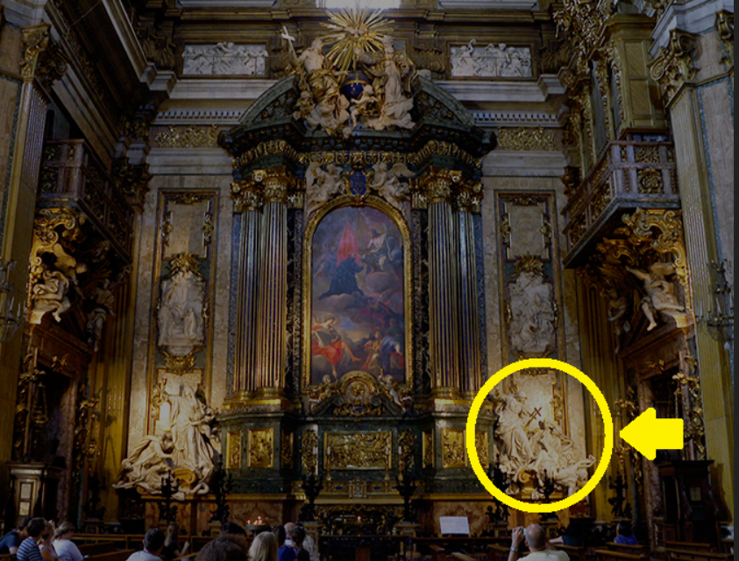
***

Walking Tours of Rome

I looked up Inquisition (The Licensed Torture, Maiming, And Murder Of Protestants) by the satanic Roman Catholic 'church' and communist, left leaning Wikipedia makes it sound like a simple question answer session:

https://en.wikipedia.org/wiki/Inquisition
The Inquisition was a Catholic judicial procedure where the ecclesiastical judges could initiate, investigate and try cases in their jurisdiction. Popularly it became the name for various medieval and reformation-era State-organized tribunals whose aim was to combat heresy, apostasy, blasphemy, witchcraft, and customs considered to be deviant, using this procedure. Violence, isolation, torture or the threat of its application, have been used by the Inquisition to extract confessions and denunciations. Studies of the records have found that the overwhelming majority of sentences consisted of penances, but convictions of unrepentant heresy were handed over to the secular courts for the application of local law, which generally resulted in execution or life imprisonment.[1][2][3]

The whitewashing of history by the Globalist/Communists/satanic pedophile loving 'leftest' is astonishing.

Here are some examples of the Roman Catholic Inquisitions:

Imtiaz Mahmood

“The Chair of Inquisition” or “the witches chair”
This is one of the many devices the Catholics used during the Spanish Inquisition era. The Spanish Inquisition was developed by the Roman Catholic. They used the chair to gain confessions from women accused of witchcraft or people accused of blasphemy. Then when they “confessed”, they burned them alive or behead them. “This was how many people were forced to confess the sin they didn’t commit, then burn them alive”. The chair was especially widely used by the Spanish Inquisition, Torture, terror, and imprisonment. From 1478 to 1834. The Chairs came in all sizes and shapes, with spikes, handcuffs, blocks to restrain the victims, and iron seats.

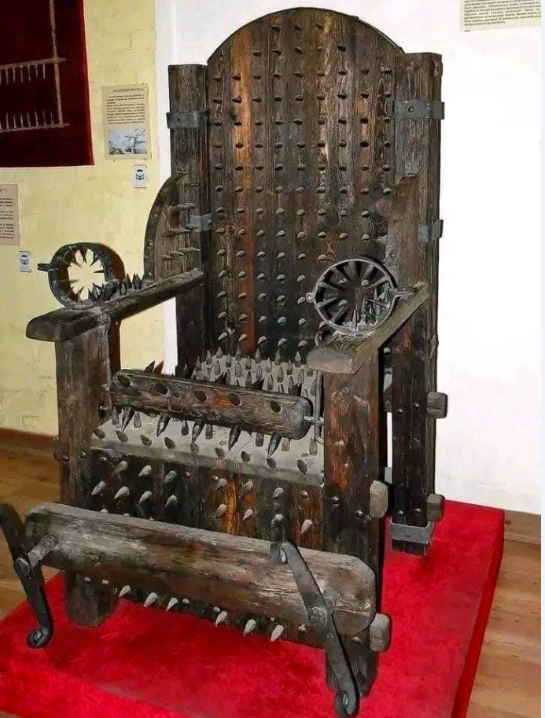

The Catholic Inquisition, Methods Of Torture And Victims
https://archive.ph/AlRZt#selection-727.0-727.56

From Sardesais to Ribeiros
https://archive.ph/Jw0zV#selection-1609.0-1609.26

The Horrors of the Church and Its Holy Inquisition
https://archive.ph/gMxtD#selection-1833.0-1833.50

10 Torture Devices Used By The Catholic Church In The Inquisition
https://www.alemattec.com/10 Torture Devices Used By The (Roman) Catholic Church In The Inquisition, February 24, 2015.pdf

Stew Peters--Jesuit Order--Our Forefather's Warning. A Scholarly Look Into the Historical Record of Subversion, April 14, 2022 . . .

https://www.alemattec.com/Stew-Peters--Jesuit-Order--Our-Forefather's-Warning-a-Scholarly-Look-Into-the-Historical-Record-of-Subversion,-April-14,-2022.htm

History from the time of the Protestant Reformation -- the Papacy, Vatican's Secret Societies including the Jesuits and their New World Order. . .
https://www.alemattec.com/History%20from%20the%20time%20of%20the%20Protestant%20Reformation%20--%20the%20Papacy,%20Vatican's%20Secret%20Societies%20including%20the%20%20Jesuits%20and%20their%20New%20World%20Order.htm

Why were the Protestants forefathers burned to the stake.doc
https://www.alemattec.com/Why were the Protestants forefathers burned to the stake.doc

--
Paul (<:) Jesus first!
www.Alemattec.com

